COVID 19 CASES ANALYSIS

DATA ANALYTICS WITH COGNOS- GROUP2

PHASE-5

**OBJECTIVES:**

This project aims to perform a comprehensive analysis of the Publicly available COVID-19 data specific to the European Union and European Economic Area (EU/EEA). The dataset provided contains vital information on the daily counts of new COVID-19 cases and associated deaths across various countries within the region. The primary objective is to meticulously examine and contrast the statistical properties, including the mean values and standard deviations, of both new cases and deaths reported.

By conducting this in-depth analysis, we intend to uncover patterns, variations, and potential insights within the data. This exploration will not only enhance our understanding of the COVID-19 dynamics in the EU/EEA but also facilitate evidence-based decision-making and the formulation of targeted strategies to address the ongoing pandemic's impact on this region.

# DESIGN THINKING:

To solve the problem of conducting an in-depth analysis of COVID-19 cases and deaths in EU/EEA countries and comparing the mean values and standard deviations, you can follow a structured data analysis process. Below are the detailed step-by-step instructions for designing a data analysis model:

# Step 1: Understand the Problem and Data

* Begin by thoroughly understanding the problem statement and the data you have. Ensure you know the scope of the analysis, data sources, and any specific requirements.

# Step 2: Data Collection and Preparation

* Acquire the COVID-19 CASES ANALYSIS dataset containing daily new cases and deaths by country in the EU/EEA.
* Perform data cleaning and pre-processing, including handling missing values, correcting data types, and removing duplicates.

# Step 3: Exploratory Data Analysis (EDA)

* Conduct initial data exploration to gain insights into the dataset. Calculate basic statistics (e.g., mean, standard deviation) and visualize data (e.g., histograms, line charts) to understand its distribution and trends.

# Step 4: Data Aggregation

* Group the data by country to calculate country-specific mean values and standard deviations for both new cases and deaths. This step involves aggregating the data at the country level.

# Step 5: Statistical Analysis

* Calculate the mean and standard deviation of new cases and deaths for each country.
* Consider using statistical tests (e.g., t-test or ANOVA) to assess if there are significant differences in means between countries or groups.

# Step 6: Data Visualization

* Create visualizations such as bar charts, box plots, or heatmaps to effectively compare and contrast the mean values and standard deviations of cases and deaths across countries.
* Use color coding or annotations to highlight key findings.

# Step 7: Time Series Analysis

* If relevant, perform a time series analysis to examine how these statistics have evolved over time. Identify trends, spikes, or seasonality patterns.

# Step 8: Outlier Detection

* Identify and investigate any outliers or anomalies in the data. Outliers may provide valuable insights or indicate data quality issues.

# Step 9: Interpretation and Insights

* Interpret the analysis results. What do the mean values and standard deviations reveal about COVID-19 cases and deaths in EU/EEA countries?
* Formulate insights and hypotheses based on your findings.

# Step 10: Report and Documentation

* Prepare a detailed report that documents the entire analysis process, from data collection to insights.
* Include visualizations, statistical analysis results, and interpretations.
* Provide actionable recommendations if applicable.

# Step 11: Stakeholder Communication

* Share the analysis results with relevant stakeholders, such as public health authorities, policymakers, or the general public.
* Ensure that the information is communicated clearly and effectively.

# Step 12: Iteration and Feedback

* Be open to feedback from stakeholders and experts, and consider refining your analysis or exploring additional questions based on their input.

# Step 13: Model Maintenance

* continuously update and maintain the analysis model as new data becomes available or as the situation evolves.

By following these steps, you can design a data analysis model that effectively addresses the problem of comparing and contrasting COVID-19 cases and deaths in the EU/EEA countries, providing valuable insights for decision-making and public awareness.

# DEVELOPMENT PHASE:



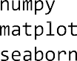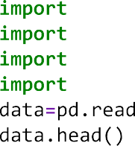





 











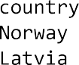































  



  



 





 



  









  













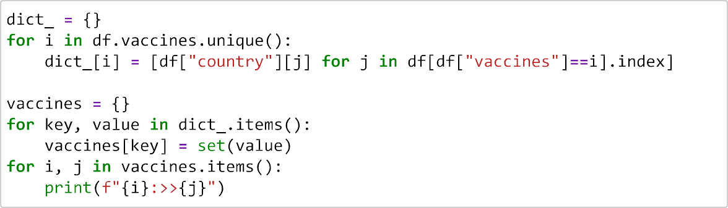





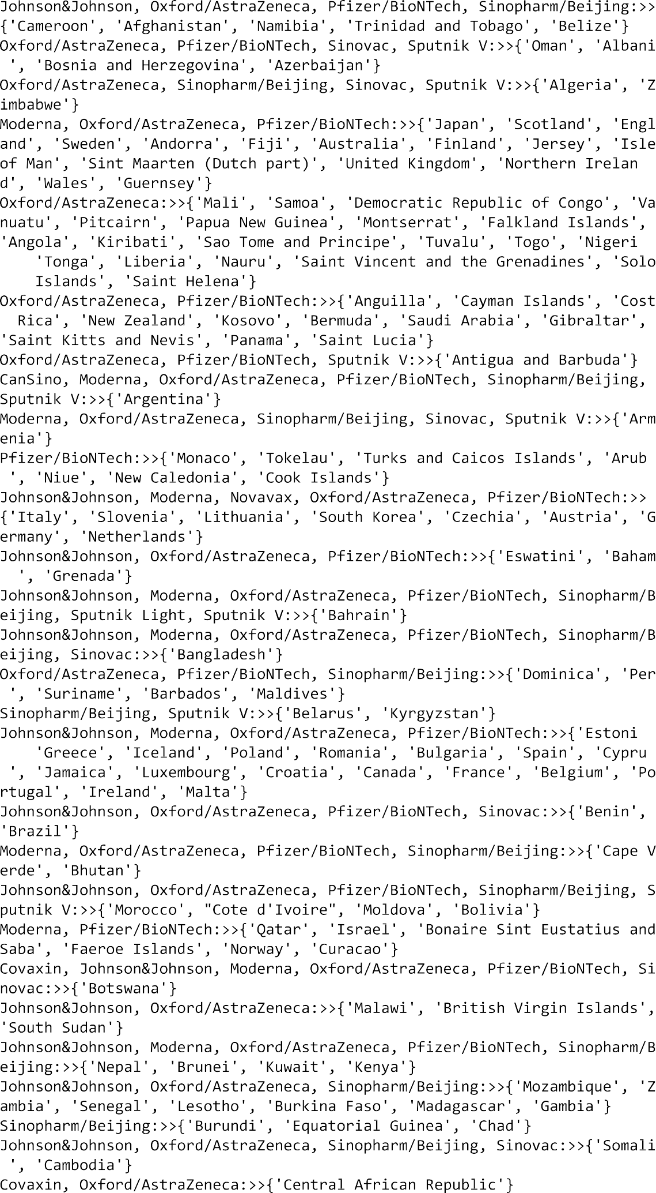



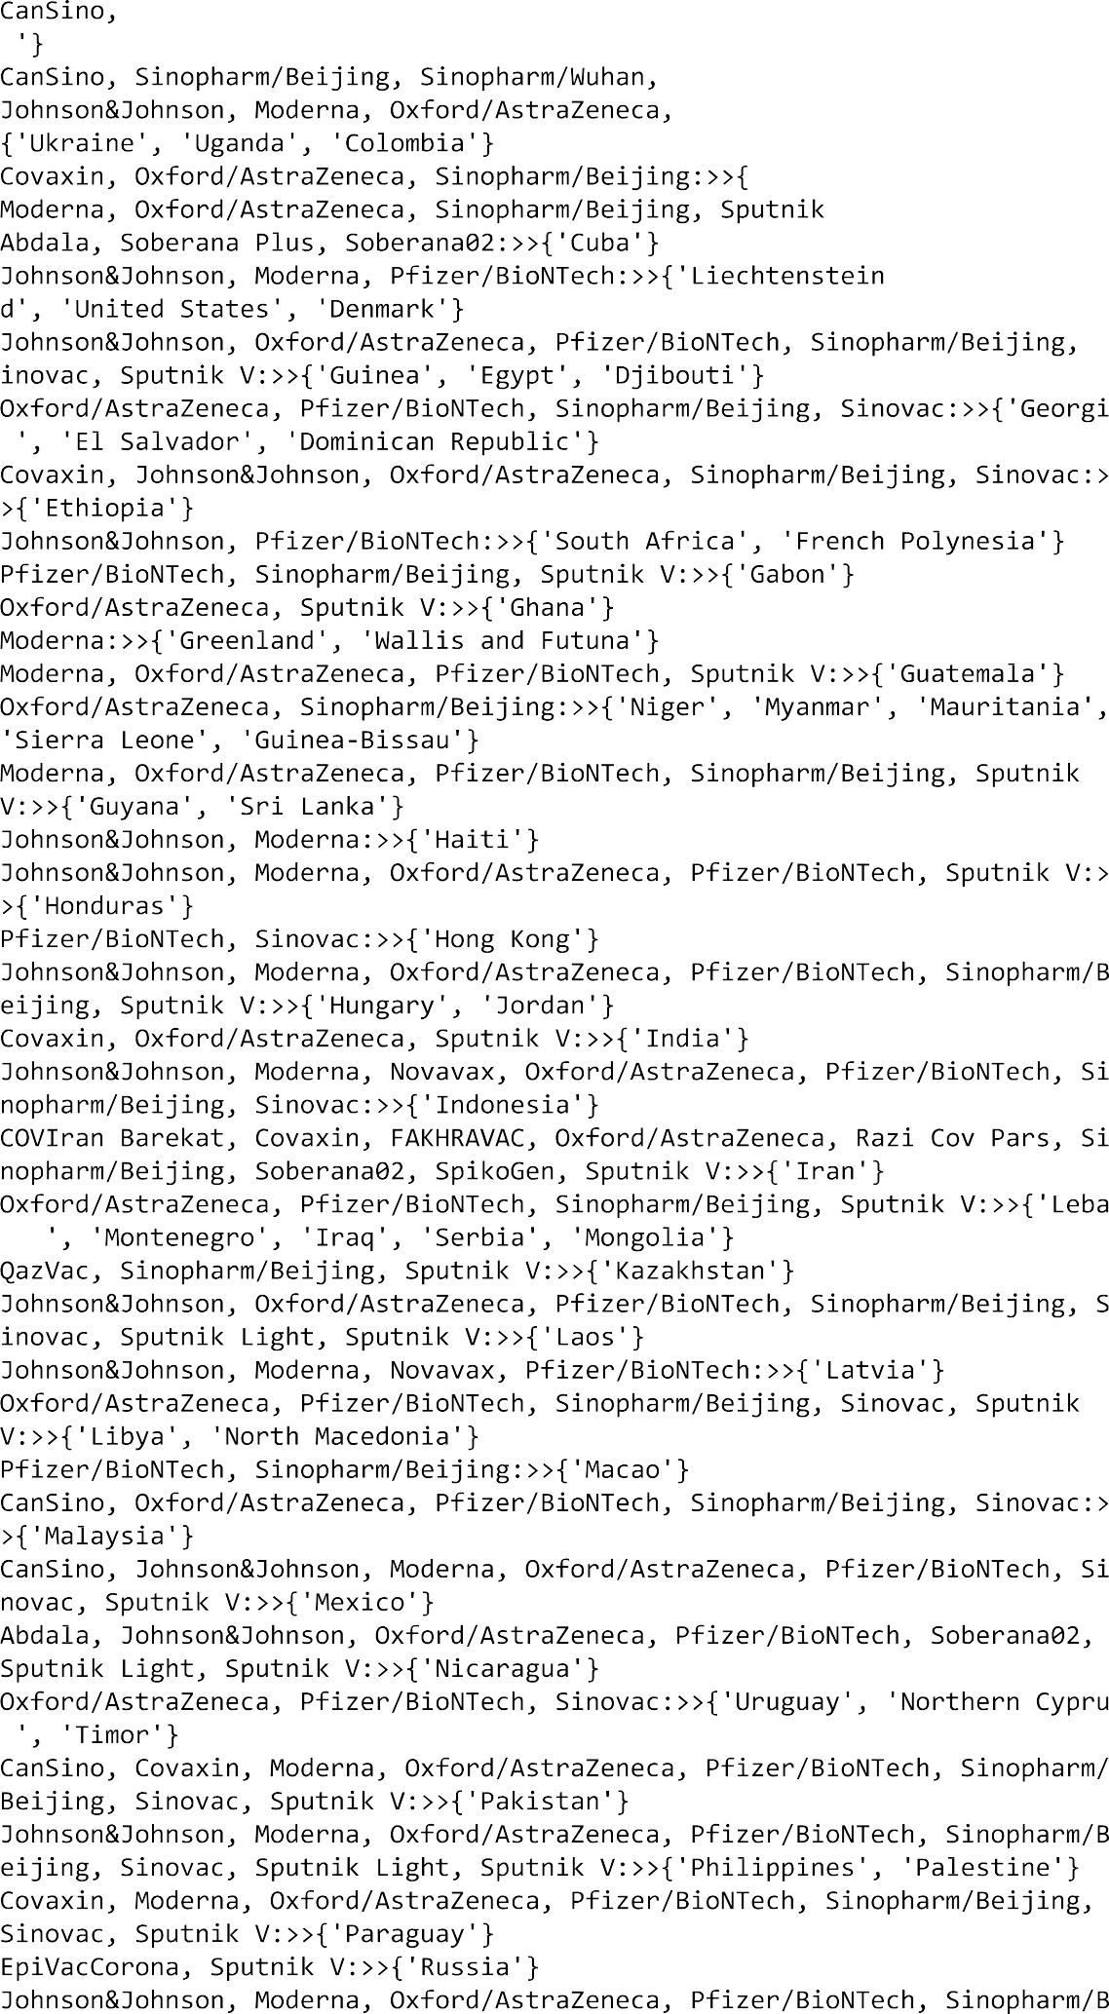



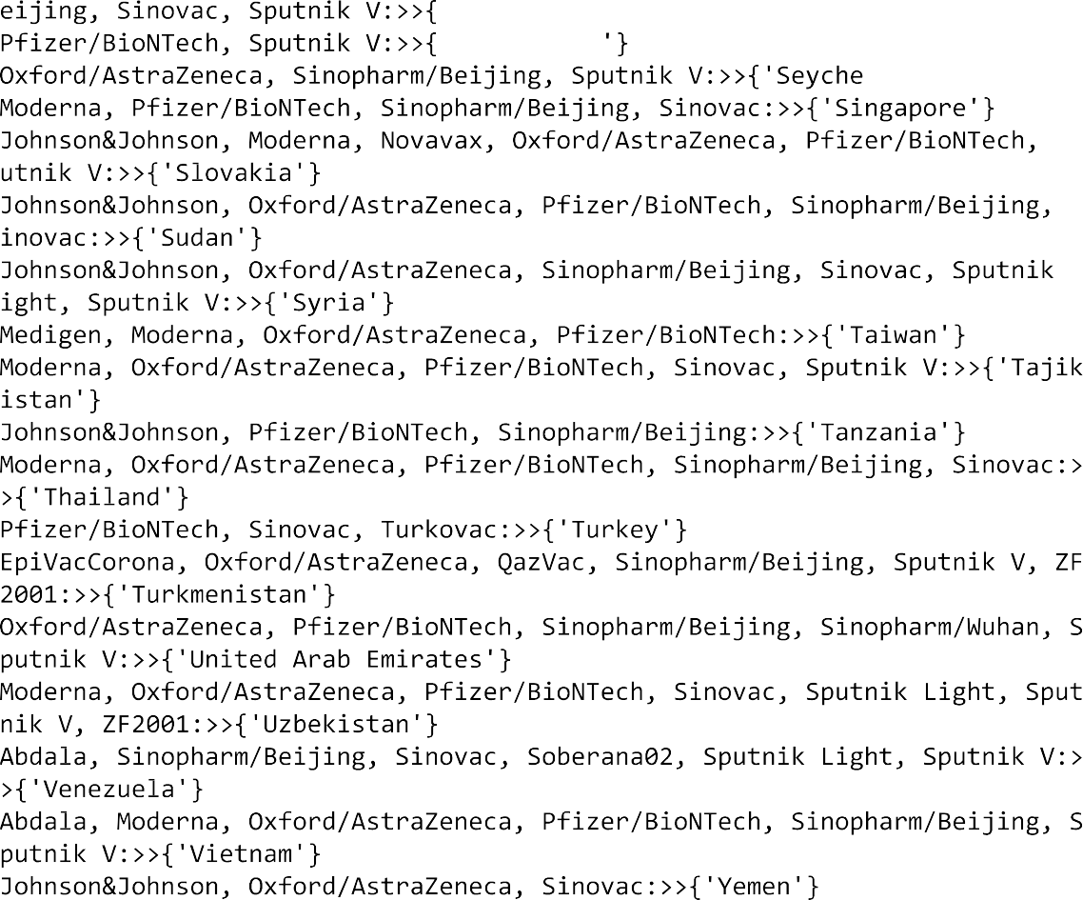

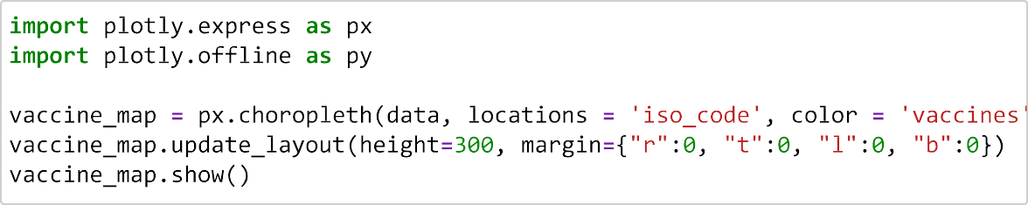





# DATA VISULAIZATION USING IBM COGNOS:

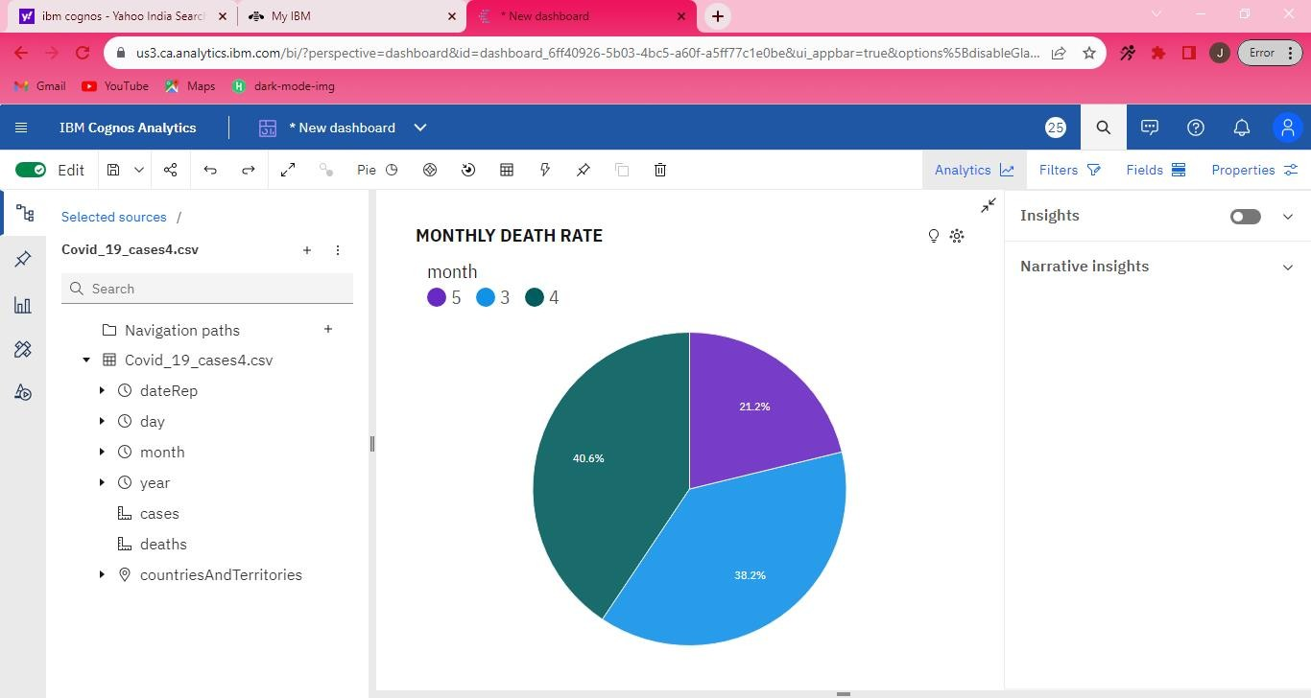

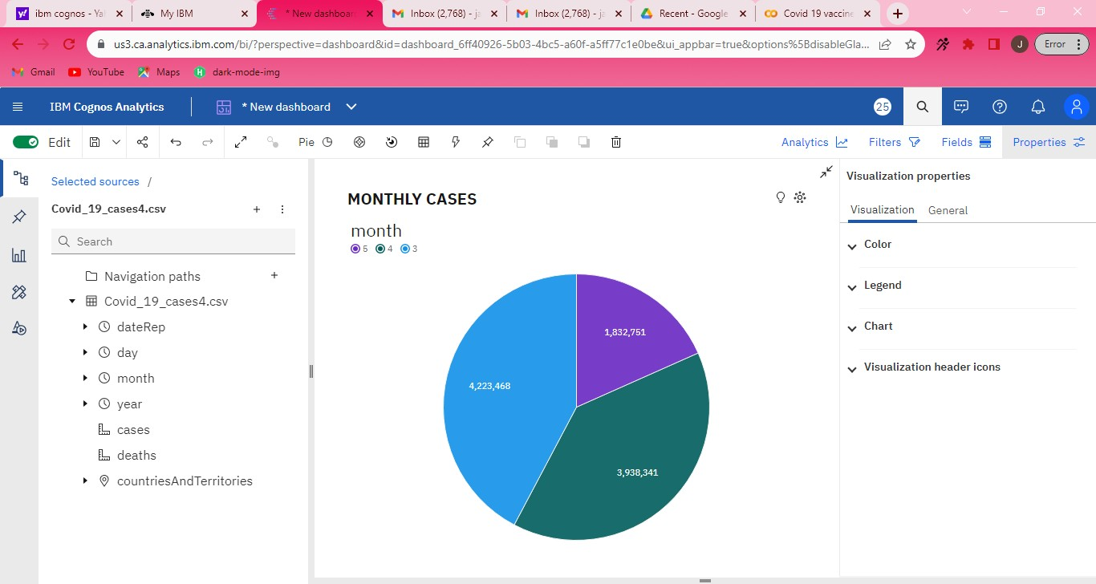

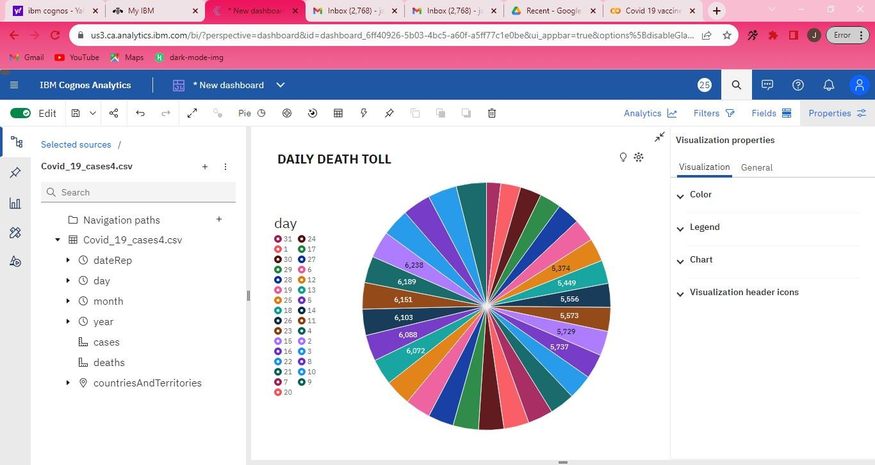

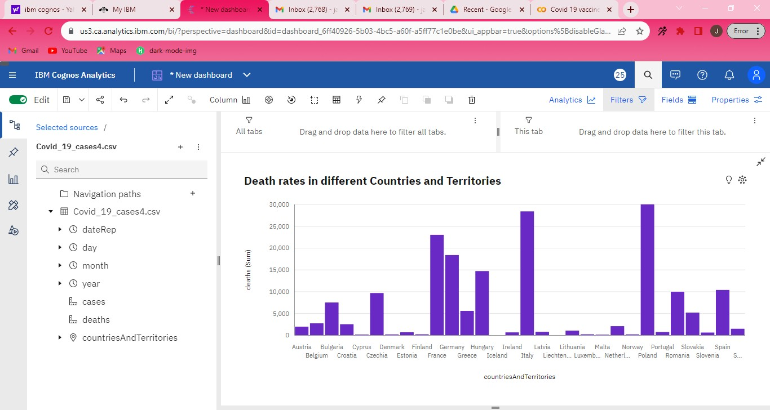

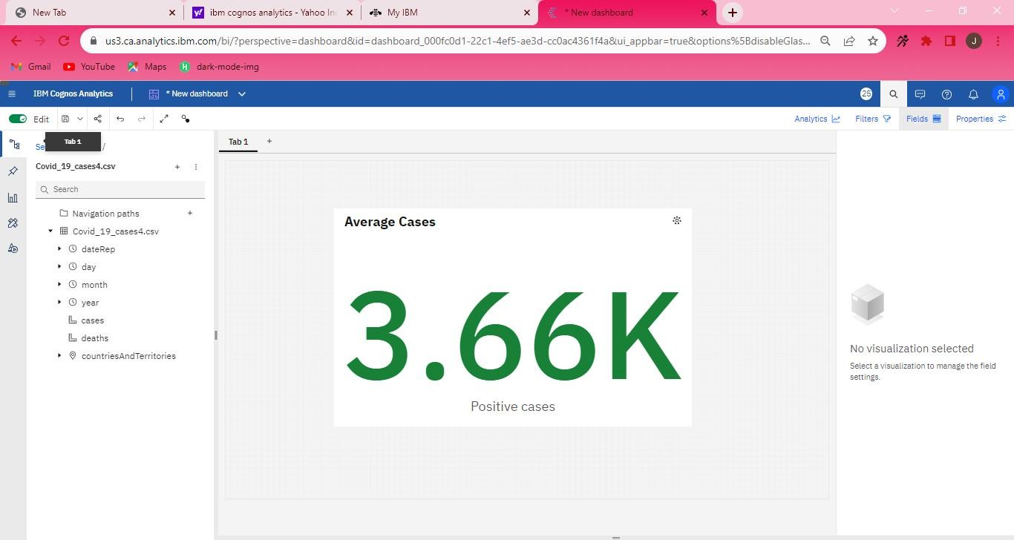

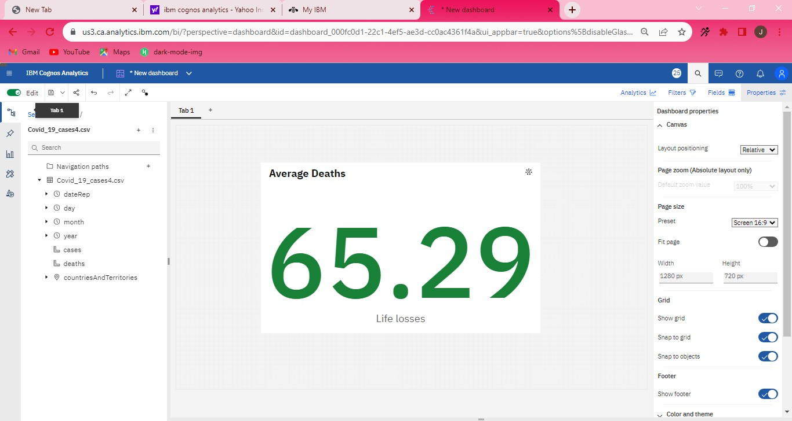

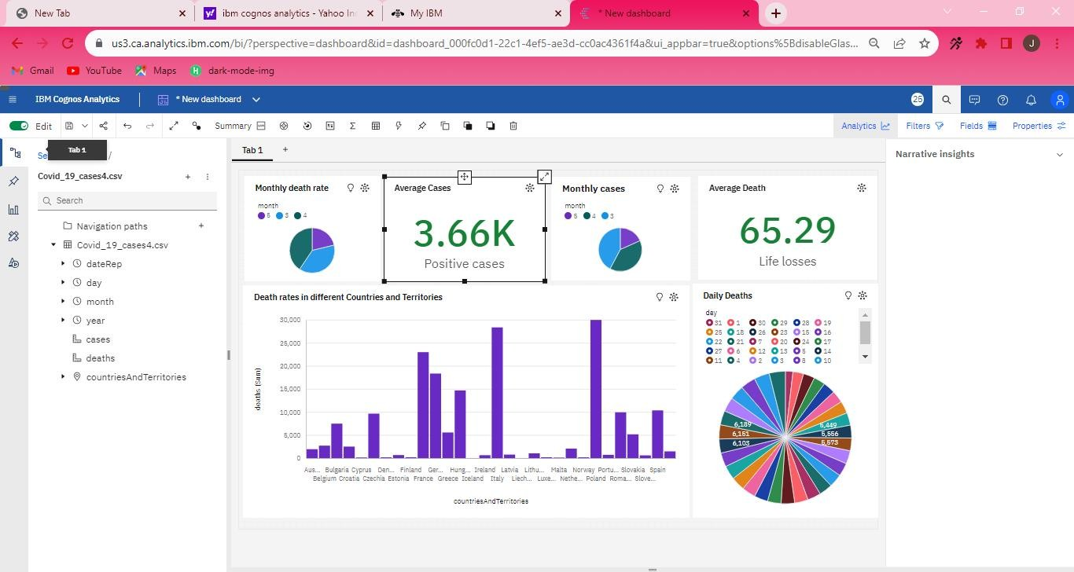

**CONCLUSION:**

The average death rate of 65.29 and 3.66K positive cases highlight the persistent threat of COVID-19. It underscores the need for ongoing vigilance, emphasizing the importance of sustained public health measures and collective efforts to curb the virus's spread and reduce its impact on communities**.**

The trend in deaths shows a weak downward trajectory, with forecasts suggesting an anticipated figure of nearly 5,500 deaths by day 38. Across all days, the cumulative death toll surpasses 178,000, varying from almost 3,500 on day 31 to nearly 7,000 on day 9.

The projected data indicates that by 2021-06-19, Germany will surpass Poland by 45 deaths. The death toll is notably high in countries such as Poland, Italy, and France, where the combined fatalities total over 81 thousand, representing 45.6% of the overall deaths.